LAB 2: PROGRAMS ON BASIC PROGRAMMING CONSTRUCTS LIKE BRANCHING AND LOOPING

Name: Shreyas Sawant Div: D7A Roll No.: 55

Decision Making

Q 1. Write a Program to check if the Triangle can be drawn or not if yes give the type of triangle.

CODE:

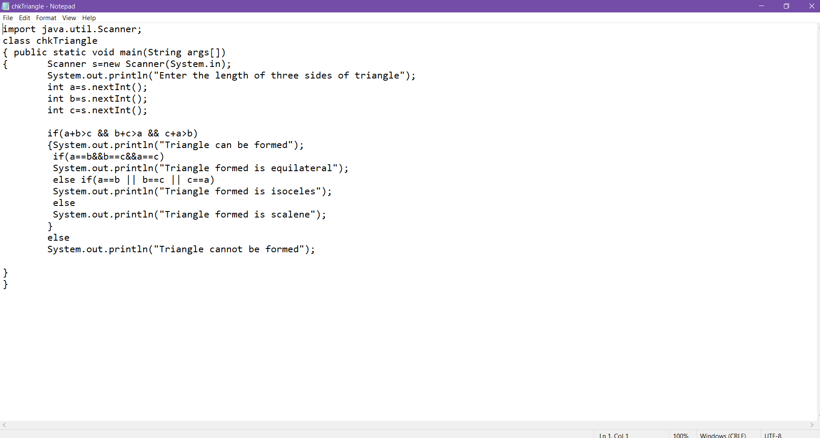

OUTPUT

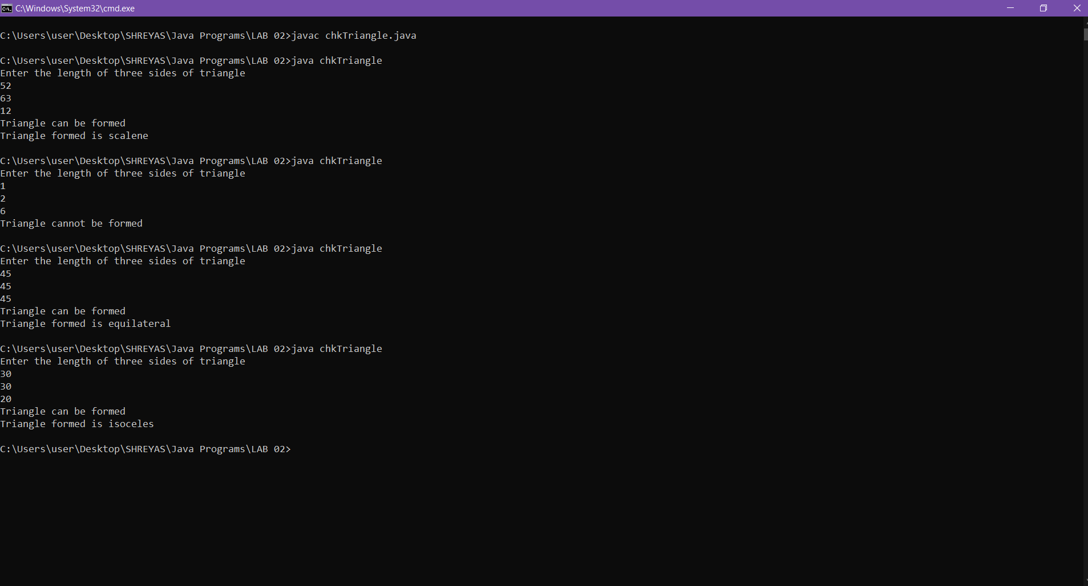

Q 2. Write a Program to check if the Voter is eligible for voting or not if yes print the details like name, age, contact no. etc.

CODE:

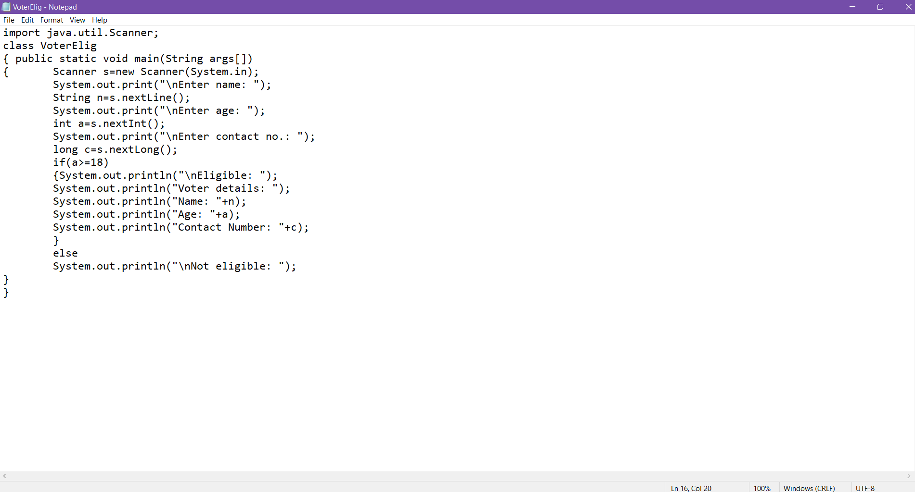

OUTPUT:

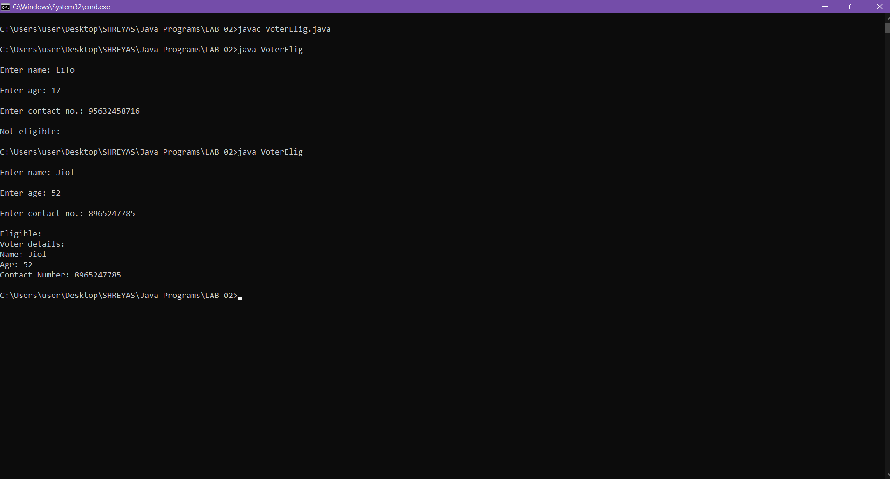

Q3. Write a Program to print the grade of students given aggregate percentage of marks: above 80 print Merit, between 70-80 print distinction, between 60-70 print first class and so on...use else-if ladder.

CODE:

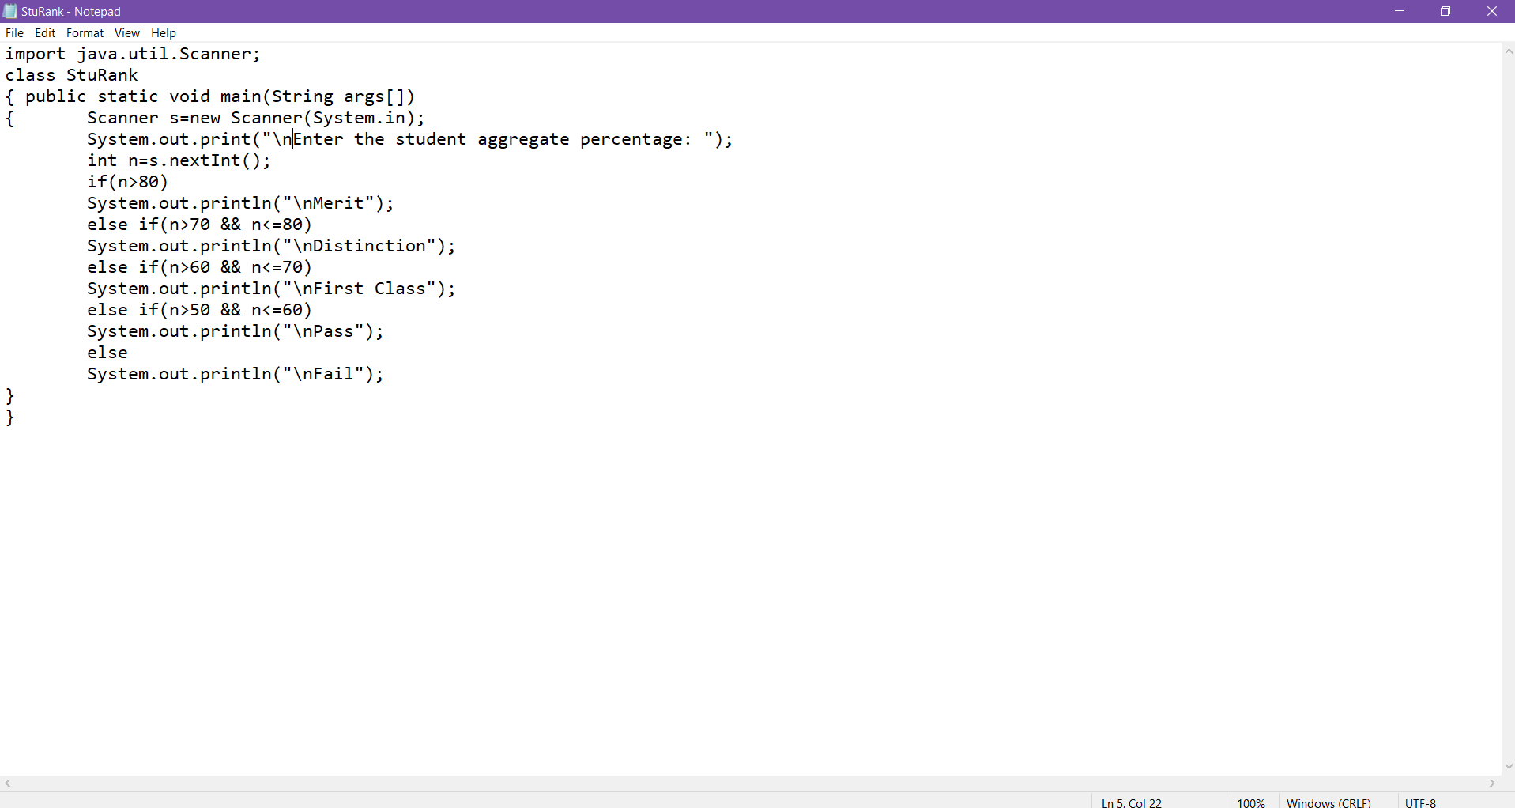

OUTPUT:

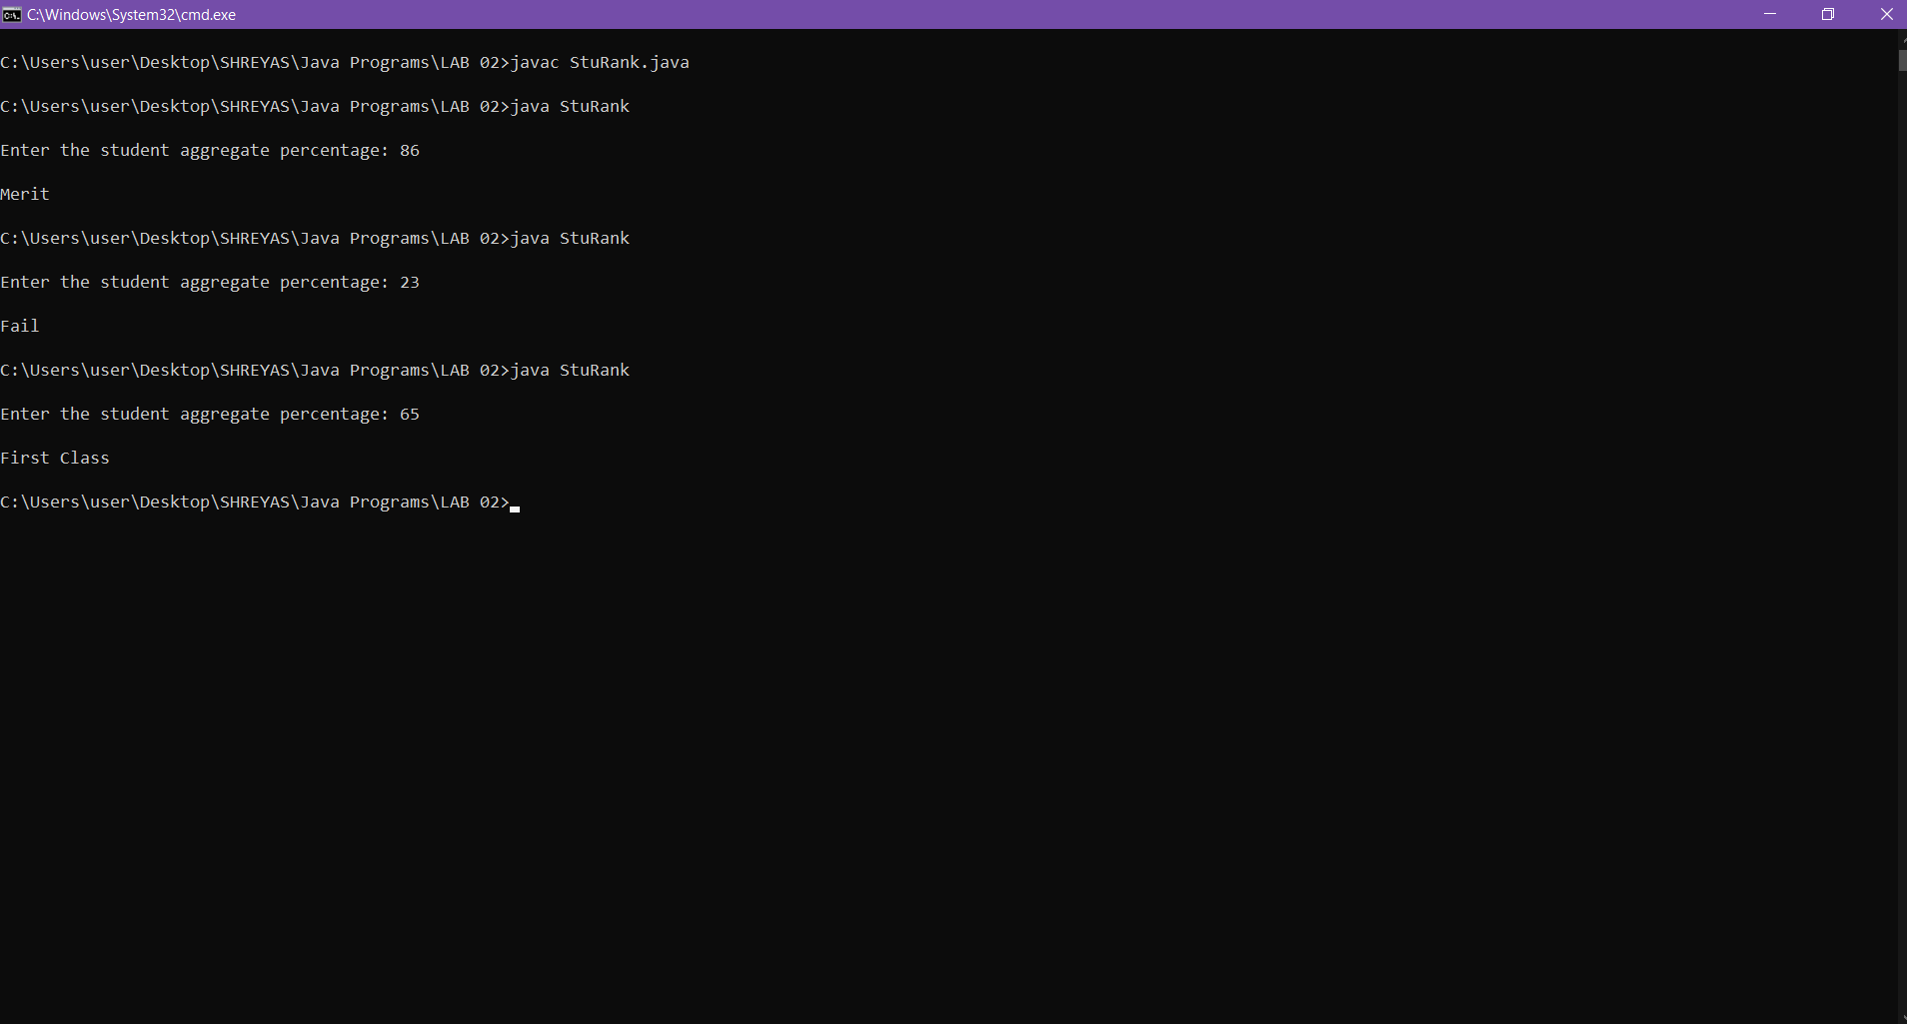4.

Q.4 Write a Program to check if the given number is positive, negative or zero.

CODE:

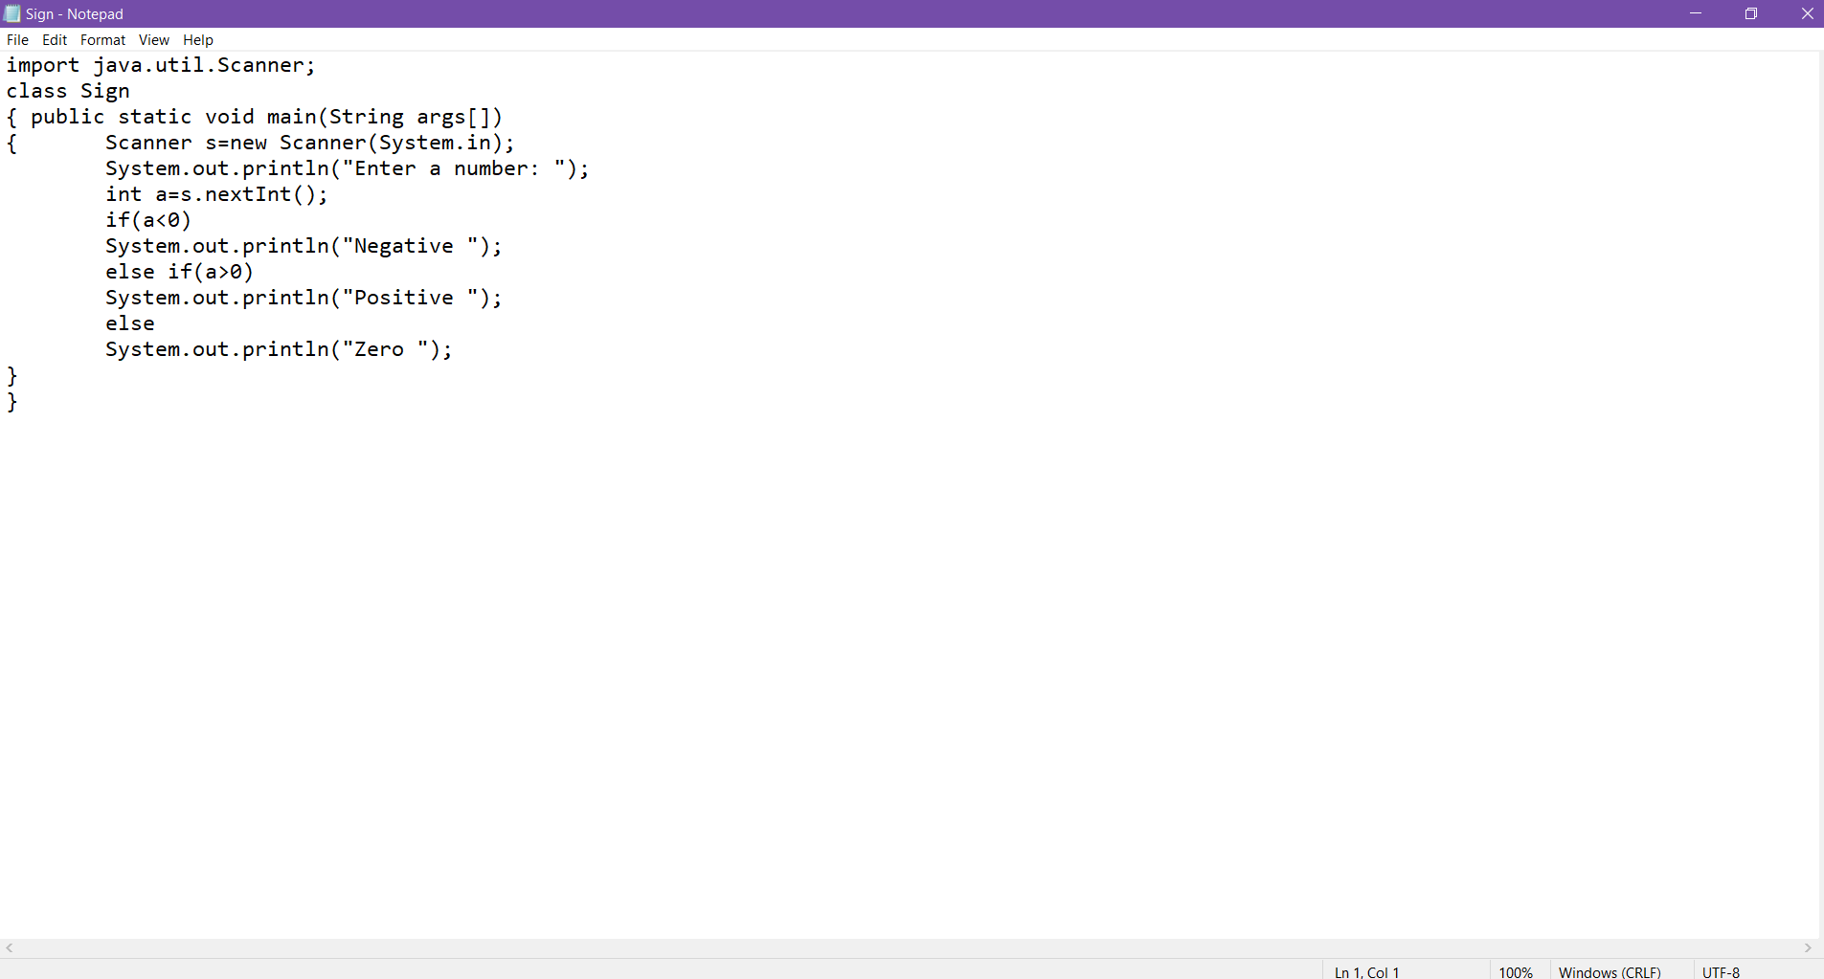

OUTPUT:

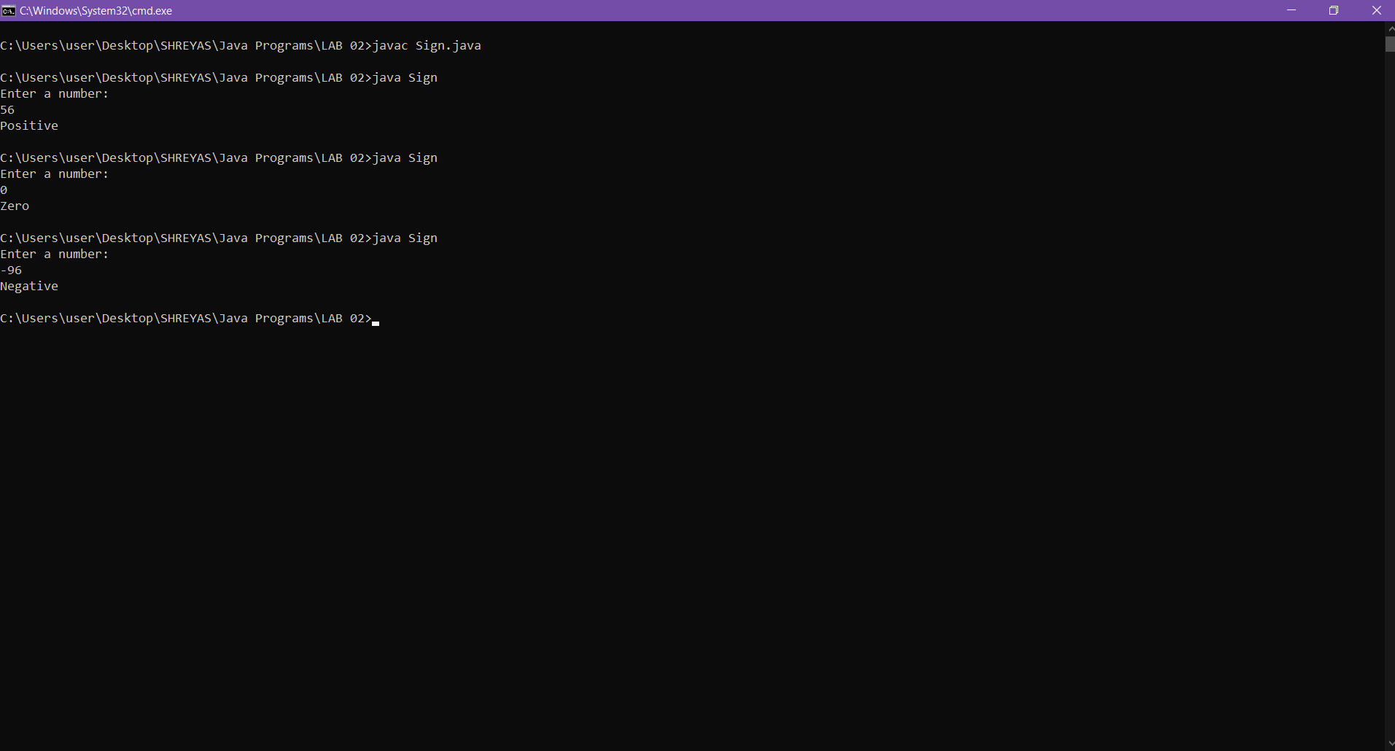

Looping

Q.1 Write a Program print all 3 digits Armstrong nos.

CODE:

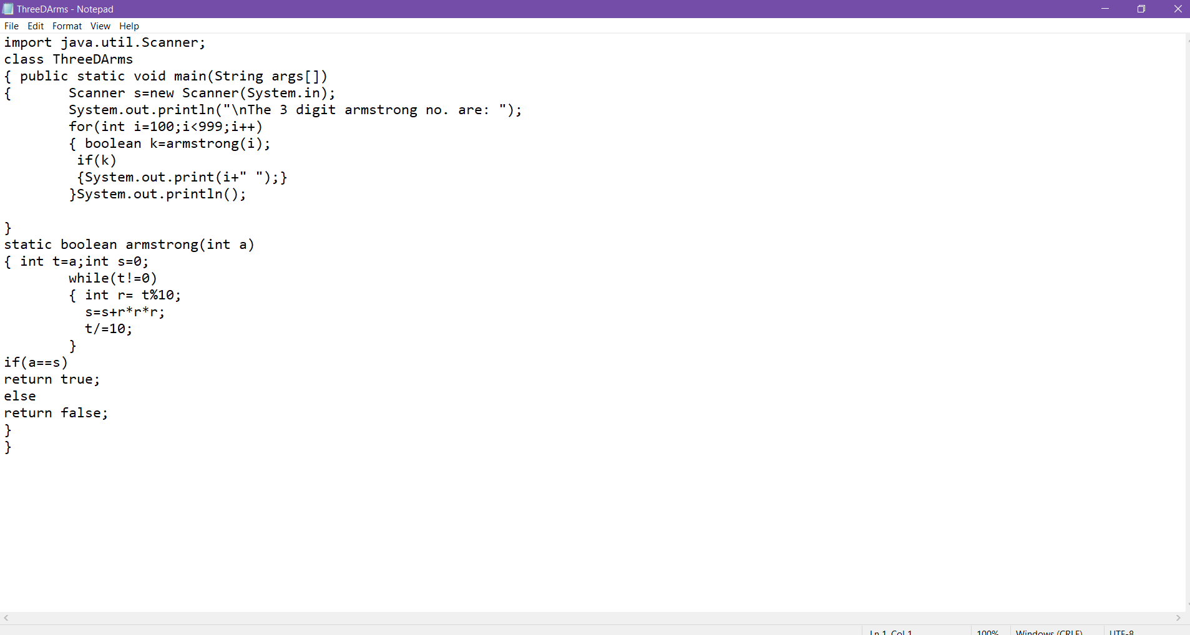

OUTPUT:

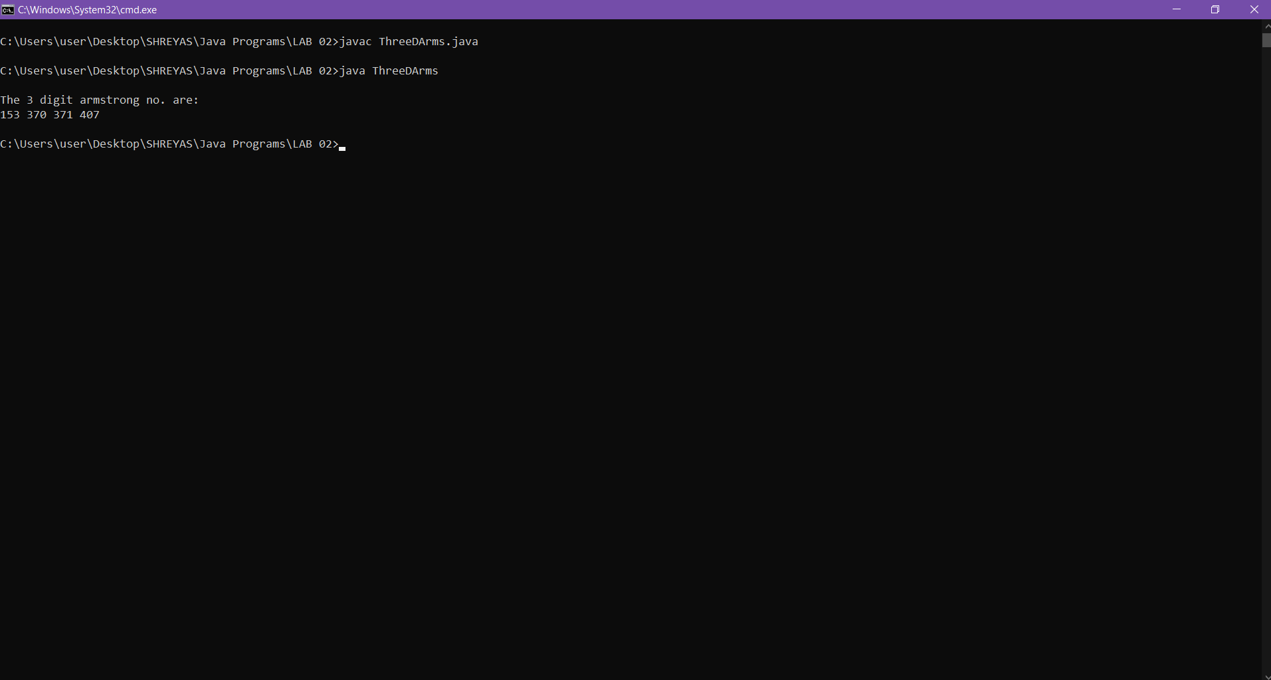

Q.2 Write a Program print first n prime numbers.

CODE:

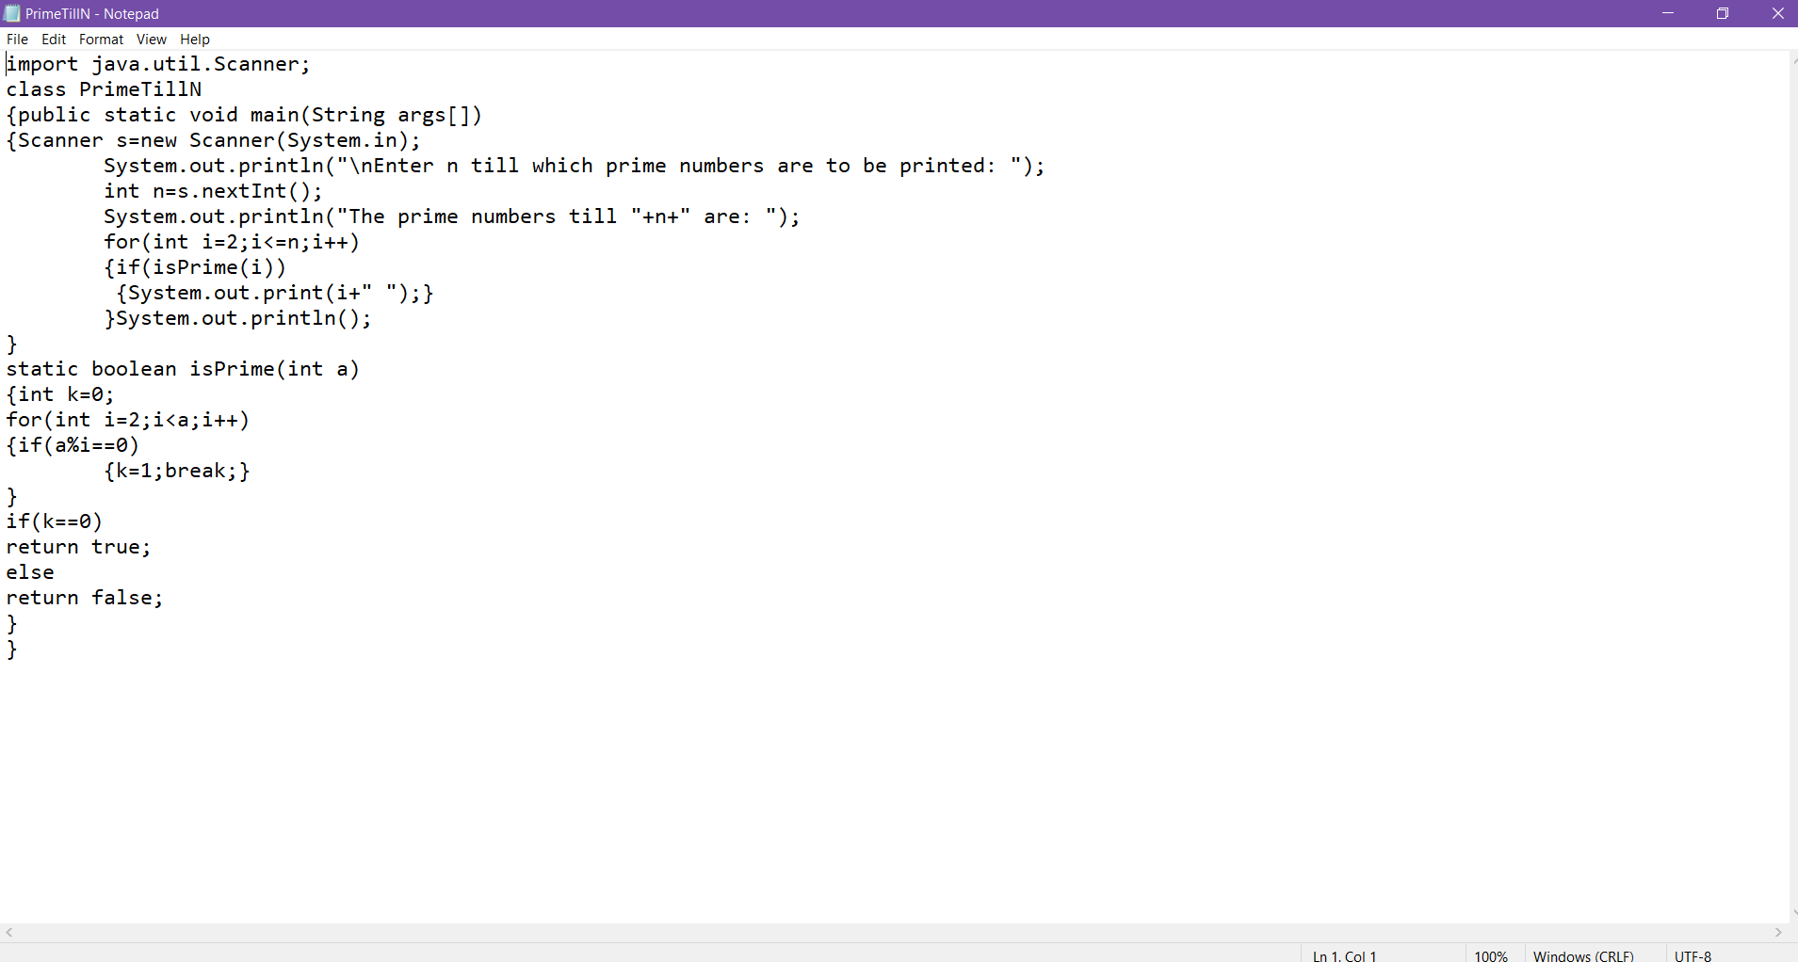

OUTPUT:

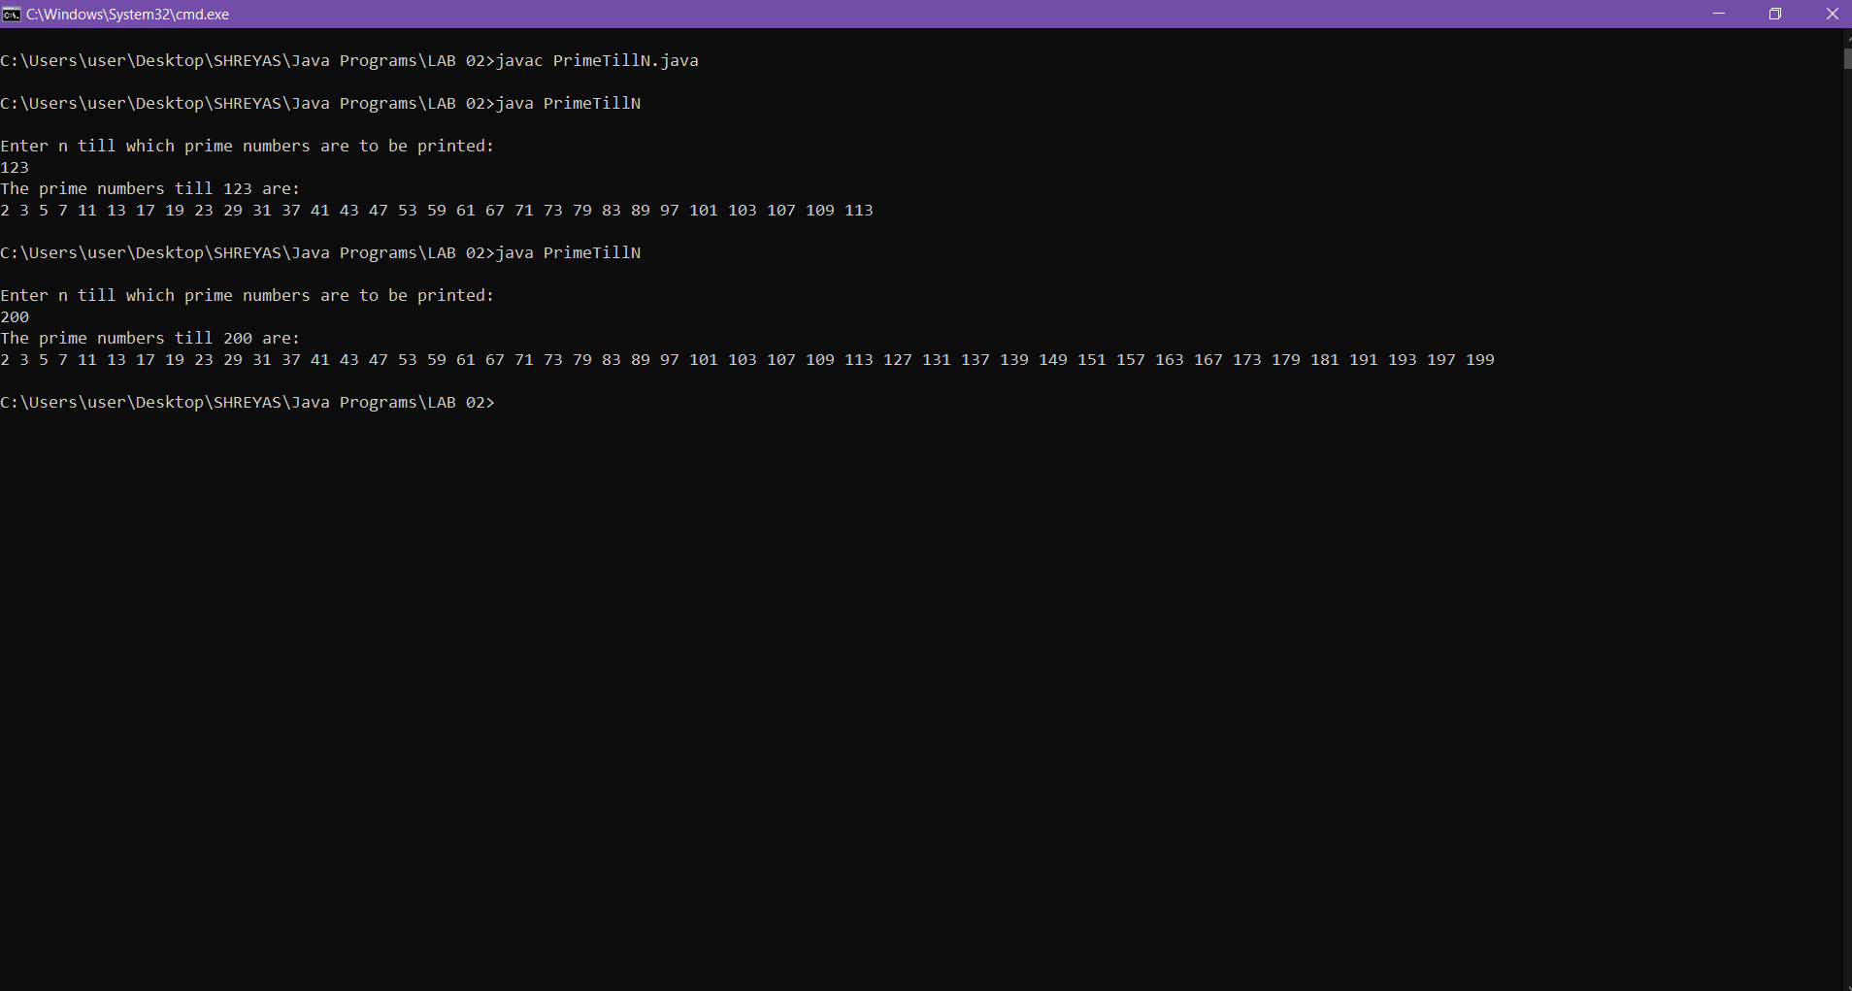

Q.3 Write a Program to simulate a simple calculator using switch case and do-while loop.

CODE:

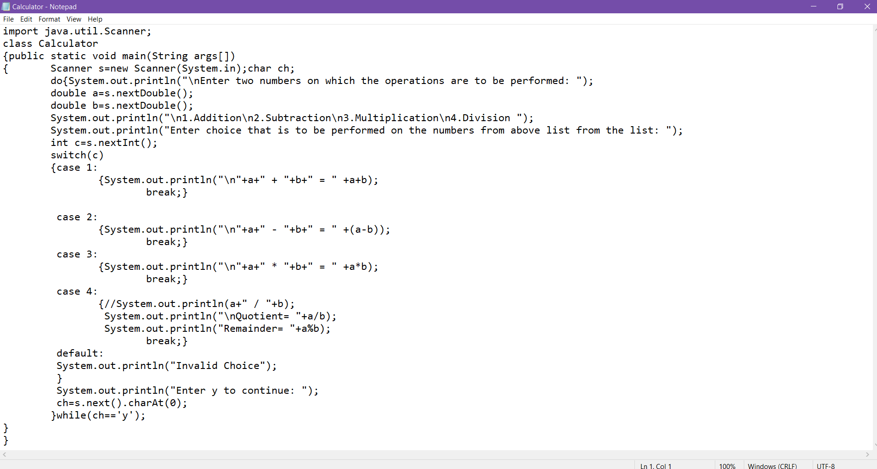

OUTPUT:

